YUVA AI INTERNSHIP PROGRAM

Python for Machine Learning
& Data Preprocessing
WEEK 1 TECHNICAL REPORT
Student Performance Dataset
This report describes a Python workflow for inspecting, cleaning, transforming, and visualizing the Student Performance dataset. Reported statistics are based on the project dataset and outputs; implementation details should be checked against the included script.

1. Project Objective
The objective of this Week 1 task is to practice core Python data-preprocessing techniques used before machine learning. The workflow loads a structured dataset, inspects data quality, checks missing values and duplicate records, encodes categorical variables, scales selected numerical features, exports a processed CSV file, and creates visualizations for exploratory data analysis (EDA).

2. Tools and Technologies
Tool | Purpose
Python | Runs the preprocessing workflow.
Pandas | Reads, inspects, cleans, transforms, and summarizes tabular data.
Matplotlib | Creates the grade-distribution and study-time comparison plots.
Scikit-learn | Provides MinMaxScaler for numerical feature scaling.
Git and GitHub | Support version control and project sharing.

3. Dataset Description
The project uses the Student Performance mathematics dataset, commonly distributed as student-mat.csv and associated with the UCI Machine Learning Repository. It contains student demographic, family, school, and study-related attributes alongside period grades.
Dataset detail | Description
Input file | student-mat.csv
Delimiter | Semicolon (;)
Records | 395 student records
Original columns | 33
Grade columns | G1 (first period), G2 (second period), G3 (final grade)
Grade scale | 0–20
Place student-mat.csv beside preprocessing.py when running the script, unless the input path in the script has been changed. If the raw dataset is not included in the public repository, obtain it from the official source and place it in the project folder.

4. Data Inspection and Quality Checks
The reported inspection of the raw dataset found 395 rows and 33 columns, with no missing values and no exact duplicate rows. The script also includes missing-value handling for cases where missing entries occur in a modified or different input dataset.
Check | Reported result | Interpretation
Dataset dimensions | 395 rows × 33 columns | Records and original attributes loaded.
Missing values | 0 reported | No imputation was required for this input.
Duplicate rows | 0 reported | No exact duplicate rows were found.
Final grade (G3) | Mean ≈ 10.42; median = 11; min = 0; max = 20 | Describes final mathematics grades.

5. Preprocessing Methodology
- Dataset loading: The CSV is read with a semicolon delimiter (sep=';') so fields are parsed into the expected columns.
- Inspection and quality checks: The workflow inspects column types, missing values, and duplicate records.
- Missing-value handling: Where needed, numeric columns can be filled using their median and categorical columns using their mode or a fallback value, according to the script.
- Duplicate removal: Exact duplicate rows are removed with drop_duplicates(). The reported source dataset contained no duplicates.
- Categorical encoding: Categorical columns are converted into numeric indicator columns using pandas get_dummies with drop_first=True and integer output.
- Feature scaling: MinMaxScaler is applied to selected numeric columns, while G1, G2, and G3 are retained on their original 0–20 grade scale.
- Output export: The transformed data is written to outputs/student_performance_preprocessed.csv.
The reported processed output contains 395 rows and 42 columns. The exact columns scaled and encoded should be confirmed against preprocessing.py, as transformations depend on the implementation and input data.

6. Exploratory Data Analysis and Visualizations

Figure 1. Distribution of Final Mathematics Grades (G3)
The histogram summarizes how frequently final grades occur on the 0–20 scale. It helps identify common grade ranges, spread, and concentrations at particular values. A grade of zero should be interpreted carefully; the chart alone cannot establish why a student received that grade.
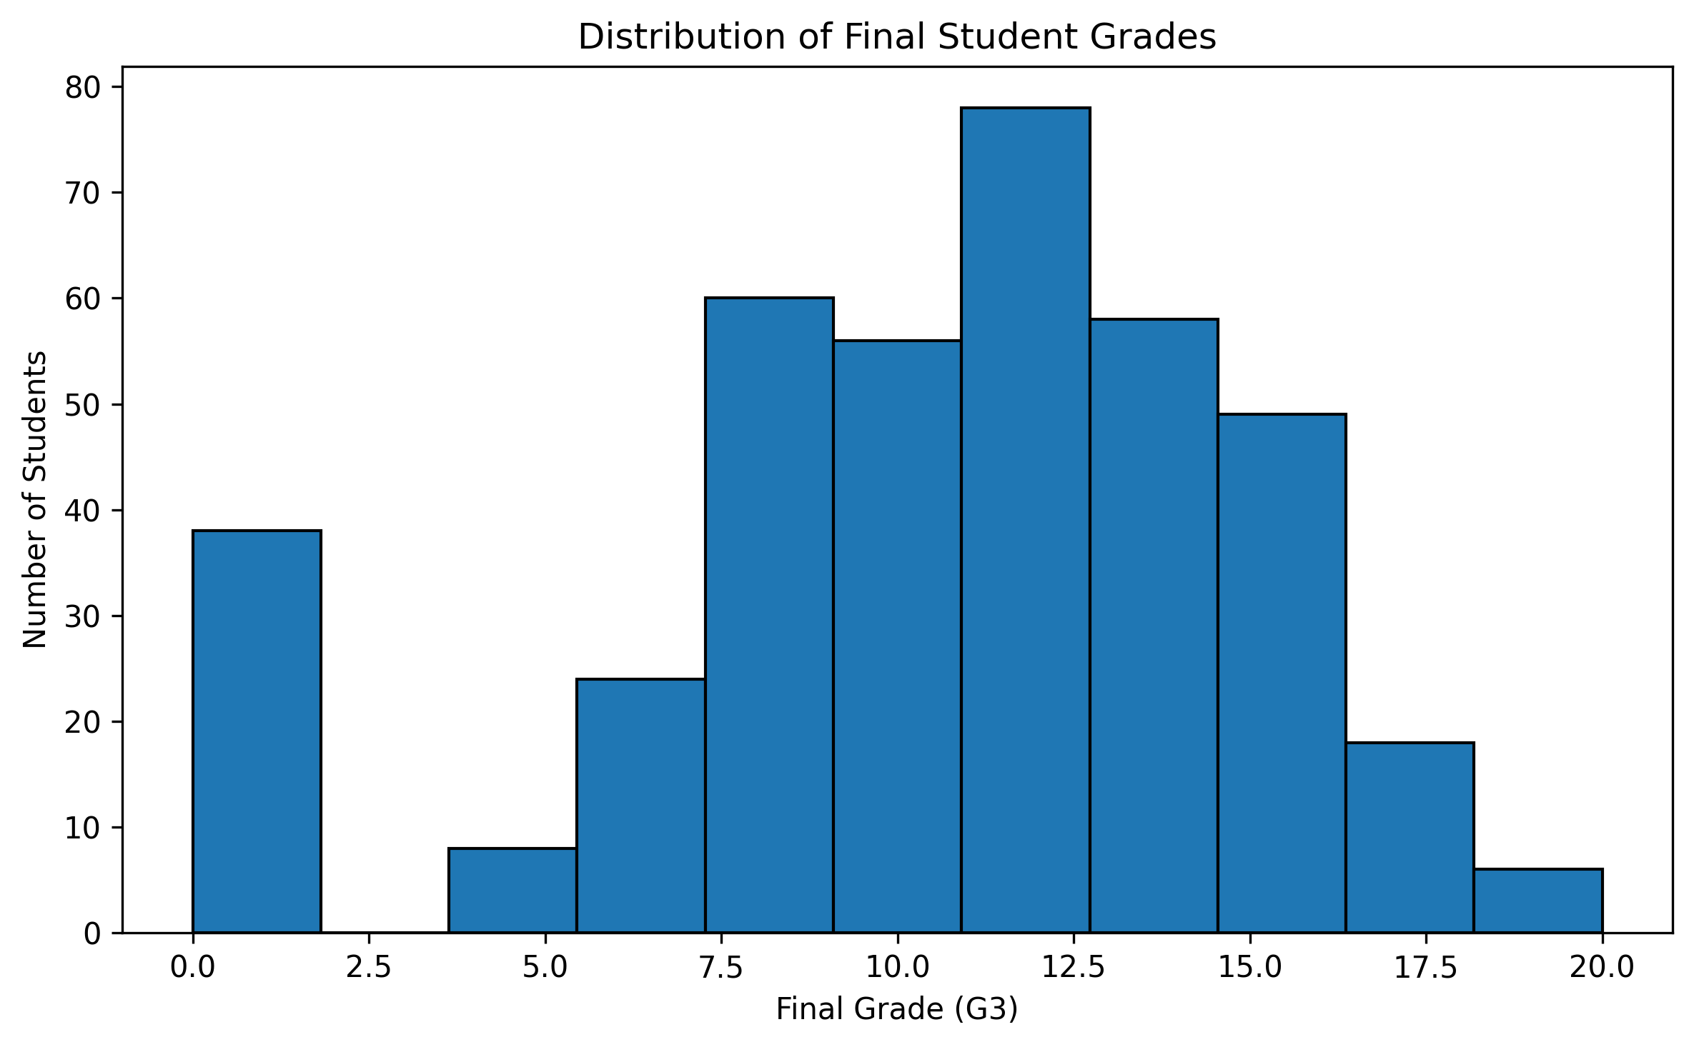
Source: outputs/final_grade_distribution.png

Figure 2. Average Final Grade by Study Time
The bar chart compares mean G3 scores across the four study-time categories represented in the dataset. The supplied project report gives approximate means of 10.05, 10.17, 11.40, and 11.26 for categories 1 through 4 respectively. These are descriptive associations and do not prove that study time alone causes differences in grades.
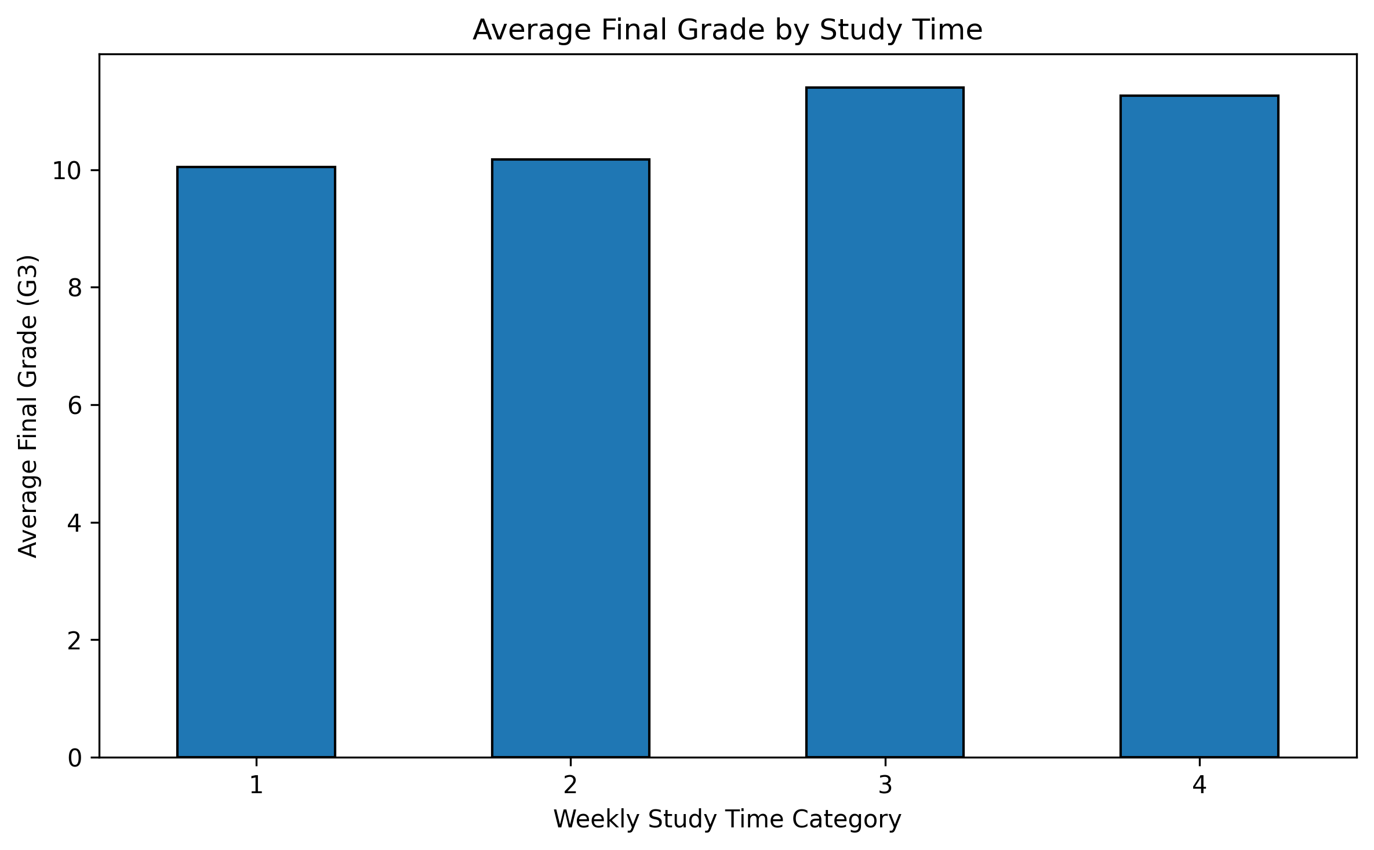
Source: outputs/average_grade_by_studytime.png

7. Pipeline Results
Metric | Raw dataset | Processed output
Rows | 395 | 395 (reported)
Columns | 33 | 42 (reported)
Missing values | 0 reported | Check generated output if input changes
Duplicates | 0 reported | Removed if present by the script
Grade scale | G1/G2/G3 on 0–20 scale | G1/G2/G3 retained on 0–20 scale
These results describe preprocessing and exploratory analysis. They do not demonstrate predictive model accuracy because model training and evaluation are outside the scope of this Week 1 task.

8. Notes and Limitations
- The analysis is descriptive and does not establish causal relationships.
- For future predictive modelling, split data into training and test sets before fitting transformations that learn from data, such as MinMaxScaler, to avoid information leakage.
- The reported numbers should be checked against the current input file and script if either is changed.
- Keep the raw dataset out of a public repository unless its redistribution terms have been checked.

9. Conclusion
This Week 1 project demonstrates a practical preprocessing workflow using Python, Pandas, Matplotlib, and Scikit-learn. The workflow loads the Student Performance dataset, performs data-quality checks, encodes categorical variables, scales selected numerical features, exports a processed CSV, and creates two visualizations. These artifacts provide a foundation for subsequent machine-learning exercises. Future model building should include a proper train/test split and evaluation process.

Dataset Reference
Cortez, P. and Silva, A. (2008). Student Performance. UCI Machine Learning Repository. Consult the official dataset page for source details and terms of use.
Project files: preprocessing.py, README.md, requirements.txt, and outputs/.

